SYSTEM DOCUMENTATION
FinTrack Prime
Overview, Problem, and Development Process

Project | FinTrack Prime
Component documented | Client-side (frontend) application
Prepared by | [Student name(s)]
Date | [Defense/submission date]

1. Project Overview
FinTrack Prime is a personal-finance web application. A user signs in, sees every account they own with its balance and recent transactions on one dashboard, and from there can plan a budget, track cash flow, and — as a paid upgrade — access four deeper planning tools: a loan calculator, an investment portfolio tracker, a retirement planner, and a full personal financial statement (net worth).
Draft for review: This section describes the problem and users in plain terms based on what the built application actually does. Please review and correct anything that doesn't match the project's intended framing.

1.1 Problem statement
Most people manage their money across several disconnected tools: a banking app for balances, a spreadsheet for budgeting, and separate calculators (or none at all) for loans, investments, and retirement planning. That fragmentation makes it hard to see the full financial picture in one place, and it discourages the kind of regular, interactive check-in that actually changes financial behavior — most people only find out they're over budget after the month is over. FinTrack Prime addresses this by putting everyday tracking (accounts, budget, cash flow) and longer-horizon planning (loans, investments, retirement, net worth) in a single, responsive web application.

1.2 Objectives
- Give a user a single, real-time view of all their accounts, balances, and recent transactions.
- Make budgeting and cash-flow tracking interactive — numbers and charts update as the user types, not only after a save completes.
- Offer deeper financial-planning tools (loan payoff, investment allocation, retirement projection, net worth) as a premium tier, unlocked by a one-time payment.
- Support account access through either a traditional email/password or a one-click Google sign-in.
- Ship as an installable, app-like experience (PWA) that still loads and navigates when the network briefly drops.

1.3 Target users
Individuals who want to track day-to-day finances and plan ahead (loans, investments, retirement, net worth) without maintaining several separate spreadsheets or apps.

2. System Scope
The application is delivered in two tiers:
Tier | Screens included
Free (every signed-in user) | Account Dashboard, Budget Planner, Cash Flow Dashboard
Premium (after upgrade) | Loan Calculator, Investment Portfolio Tracker, Retirement Planner, Financial Statement (net worth)

A non-premium user still sees the four premium tools in the sidebar, each marked with a lock icon, rather than having them disappear — so the value being offered is visible, not hidden.

3. High-Level Architecture
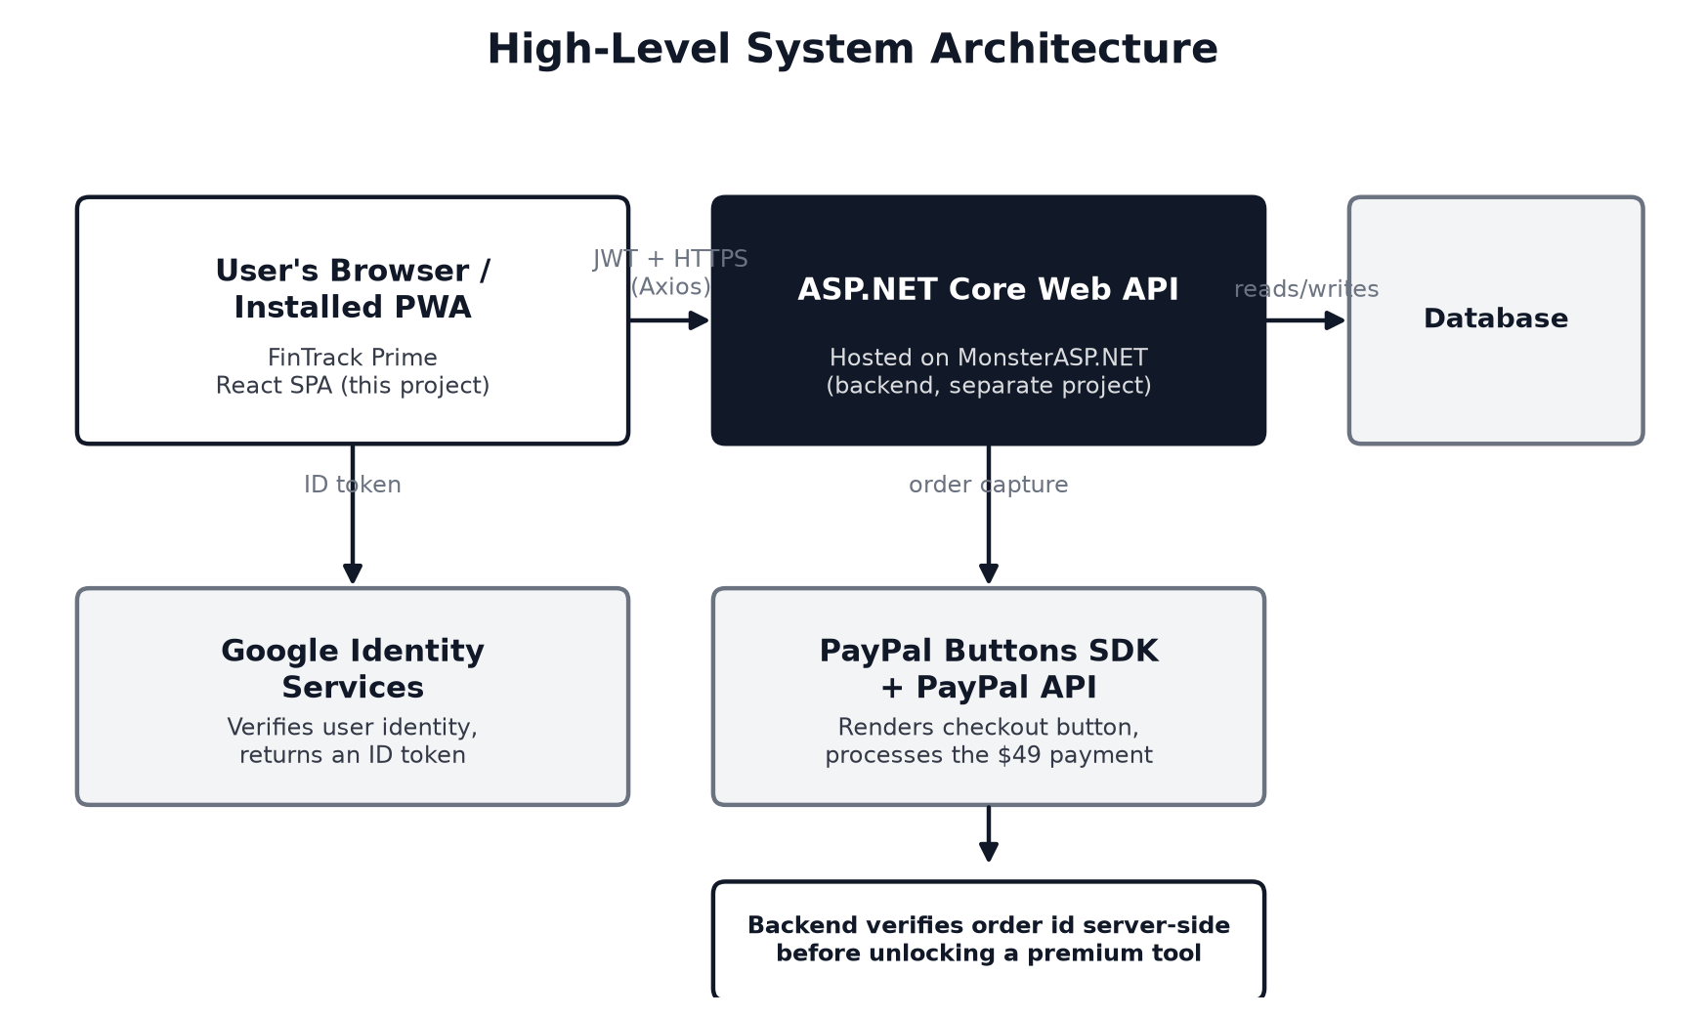
Figure 1 — The browser-based frontend, the backend API it talks to, and the two external services it integrates with.
The system has three main parts. The frontend (this project) is a React single-page application the user's browser runs, installable as a PWA. It communicates with an ASP.NET Core Web API (hosted on MonsterASP.NET), which is a separate backend project and the system's actual source of truth for data and business rules — the frontend never talks to a database directly. Two external services are integrated into the flow: Google Identity Services (identity verification for sign-in) and PayPal (payment processing for the premium upgrade).

4. Core Process Flows

4.1 Registration, login, and Google sign-in
A new user registers with a name, email, and password, or signs in with an existing account, or uses "Continue with Google" for a one-click alternative. All three paths return the same kind of session token, so the rest of the app treats them identically. The session is kept alive automatically in the background: a short-lived token refreshes itself before it expires, and if that ever fails, the user is safely returned to the login screen instead of seeing a broken page. (Full technical detail is in the Technical Documentation, Section 4.)

4.2 Premium upgrade (paywall)
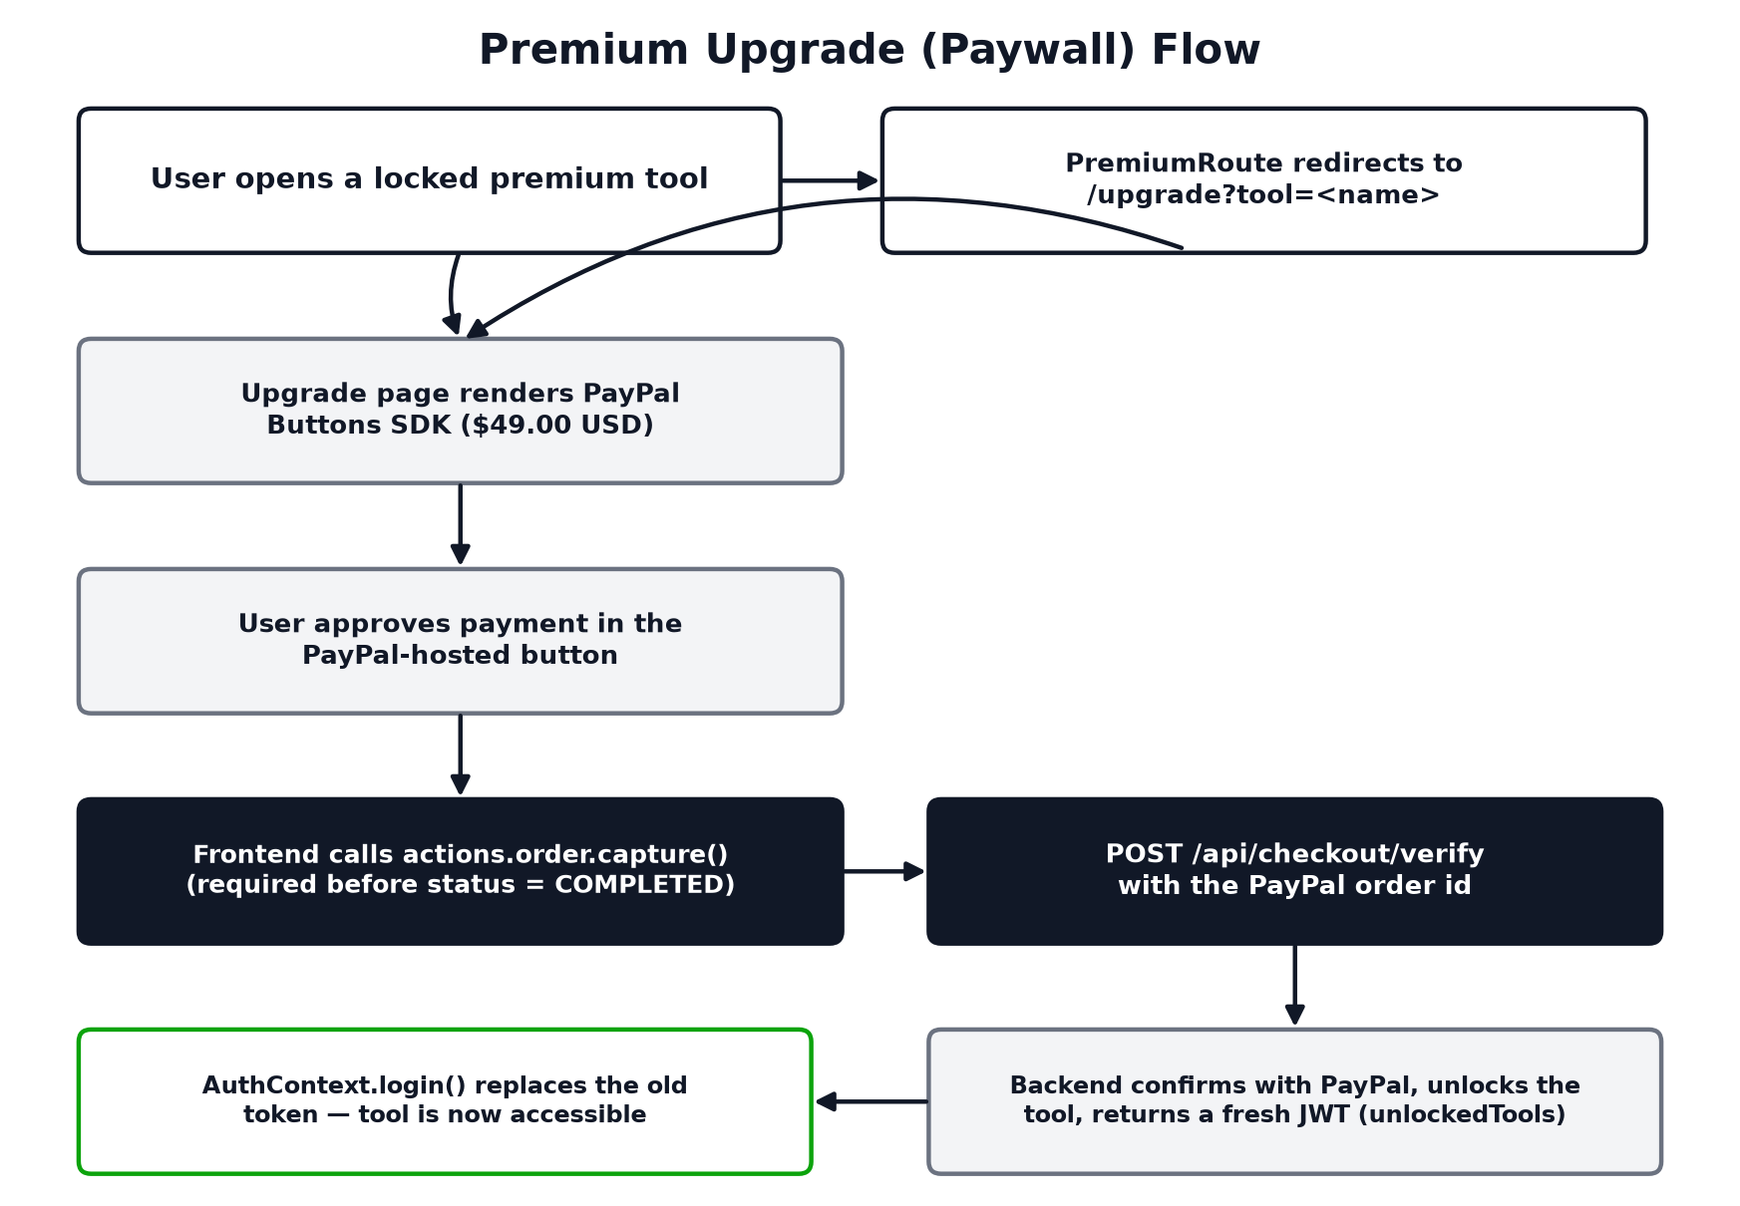
Figure 2 — What happens from clicking a locked tool to gaining access to it.
Clicking a locked premium tool sends the user to an upgrade screen instead of the tool itself. There, PayPal's own checkout button handles the payment; once approved, the app confirms the payment with the backend and immediately grants access — no separate reload or manual refresh needed.

4.3 Instant-feel editing
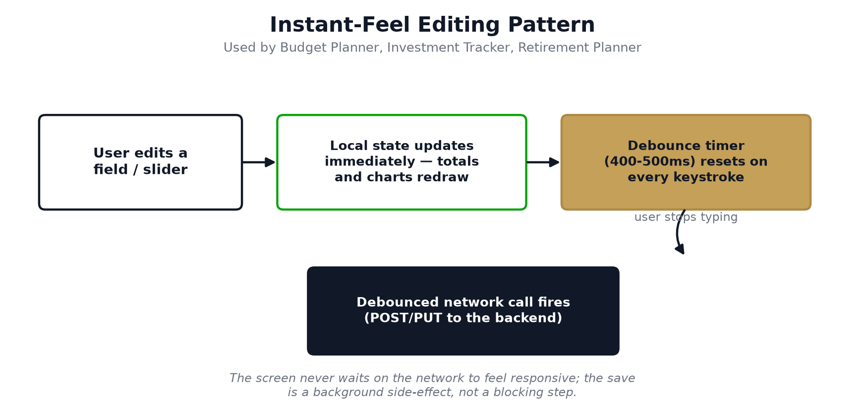
Figure 3 — Why the budget/investment/retirement screens feel responsive.
Three of the planning screens (Budget Planner, Investment Tracker, Retirement Planner) let the user edit numbers inline. Totals and charts update the instant a value changes, rather than after the data is saved to the backend — the actual save happens quietly a fraction of a second after the user stops typing.

5. Development Process
The application was built in stages, evidenced by two complementary records kept in the project itself: the feature phases described in the project README, and a set of written design documents (docs/superpowers/specs/) covering a full UI/design-system build-out.

5.1 Feature delivery phases
Phase | What it delivered
Phase 1 | Authentication (email/password + Google) and the Account Dashboard
Phase 2 | Budget Planner and Cash Flow Dashboard — the two free planning tools
Phase 3 | The premium paywall: PayPal checkout and purchase verification
Phase 4 | The four premium tools: Loan Calculator, Investment Tracker, Retirement Planner, Financial Statement

5.2 Spec-driven UI build-out with Claude Code
Separately from the feature phases above, the interface itself was rebuilt toward a consistent, professional design system using an AI-assisted, spec-first workflow with Claude Code (Anthropic's AI coding assistant). For each phase, a written design document was produced first — stating the goal, what was explicitly out of scope, and how the result would be verified — before any implementation code was written. These four documents still exist in the repository at docs/superpowers/specs/ and are the direct evidence of this process.
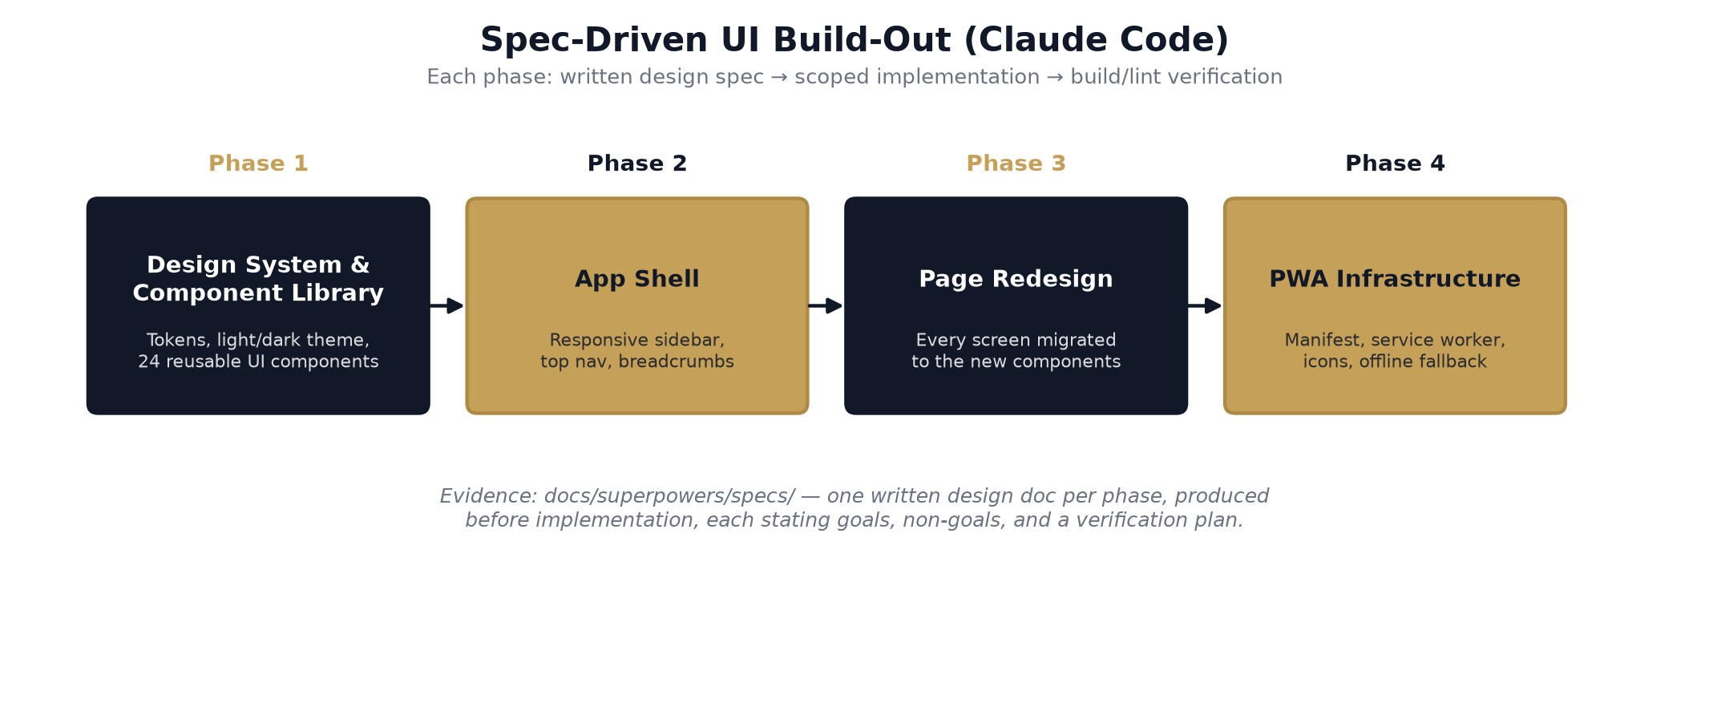
Figure 4 — The four-phase UI build-out, each phase backed by a written spec.

5.3 How Claude Code helped, concretely
- Turning an idea into a scoped plan: each spec names concrete goals and non-goals up front (e.g. Phase 1's spec explicitly excludes touching any existing page or routing), so implementation stayed contained to one concern at a time instead of sprawling.
- Preserving what already worked: the specs repeatedly call out what must carry over unchanged — the navy/gold brand colors, the guilloché motif, tabular numerals for money — so the redesign improved the interface without losing the original site's identity.
- Building the client side incrementally and safely: each of the four phases was additive and independently verifiable (a dev-only /style-guide route for Phase 1's component library, a manual keyboard/theme/responsive pass, npm run build passing) before the next phase built on top of it.
- Documenting trade-offs as they were made: decisions like "API responses are never cached offline" (Phase 4) or "icons are generated fresh rather than derived from an unrelated template asset" are written directly into the specs with their reasoning, not left implicit in code.

6. Preparations Before Building
Before implementation could begin, the following setup was required:
- A Google Cloud OAuth Web Client ID, created for this project so users could sign in with Google; its value is supplied through VITE_GOOGLE_CLIENT_ID and must match the backend's configured client id exactly.
- A PayPal Sandbox application, providing the public client id (VITE_PAYPAL_CLIENT_ID) used to render the checkout button in development.
- A running backend API to point the frontend at, configured through VITE_API_BASE_URL (a local HTTPS endpoint during development; the deployed MonsterASP.NET URL in production).
- Carrying over the original site's brand assets and identity — the navy/gold palette, the Libre Caslon Text/Public Sans type pairing, and the guilloché rosette motif — so the rebuilt interface stayed recognizably the same product.

7. Current Status & Known Limitations
- All four feature phases and all four UI build-out phases described above are complete; every backend endpoint the project defines has a corresponding frontend screen.
- npm run build (TypeScript project build + Vite production build) completes cleanly.
- No live backend was available in the development sandbox this frontend was built in, so end-to-end behavior (register → dashboard → edit a budget category → upgrade → use a premium tool) has not been click-tested against real API responses. This is called out directly in the project's own README as the next verification step once both sides are deployed together.
- Recharts alone pushes the production bundle past Vite's default 500 kB chunk-size warning; this is an accepted, known trade-off for the current scope, not a defect.

Appendix A — Glossary
Term | Meaning
JWT | JSON Web Token — a signed, short-lived access token proving who the user is.
Refresh token | A longer-lived credential, stored in an HttpOnly cookie the browser JavaScript cannot read, used to silently obtain a new JWT.
PWA | Progressive Web App — a website that can be installed and opened like a native app, with limited offline support.
Debounce | Delaying an action (like a network save) until a burst of rapid events — like typing — has paused, to avoid firing it on every keystroke.
Paywall | The upgrade screen and access checks that separate free features from the four paid premium tools.
Route guard | A component that checks a condition (logged in? premium tool unlocked?) before allowing a page to render, redirecting elsewhere otherwise.
Spec (design document) | A written plan describing what will be built and why, produced and agreed on before implementation begins.

